**Project - 1: Deploying a Multi-Tier Website Using AWS EC2**

1. We have created EC2 Instance and launch template of Ubuntu.   
     
   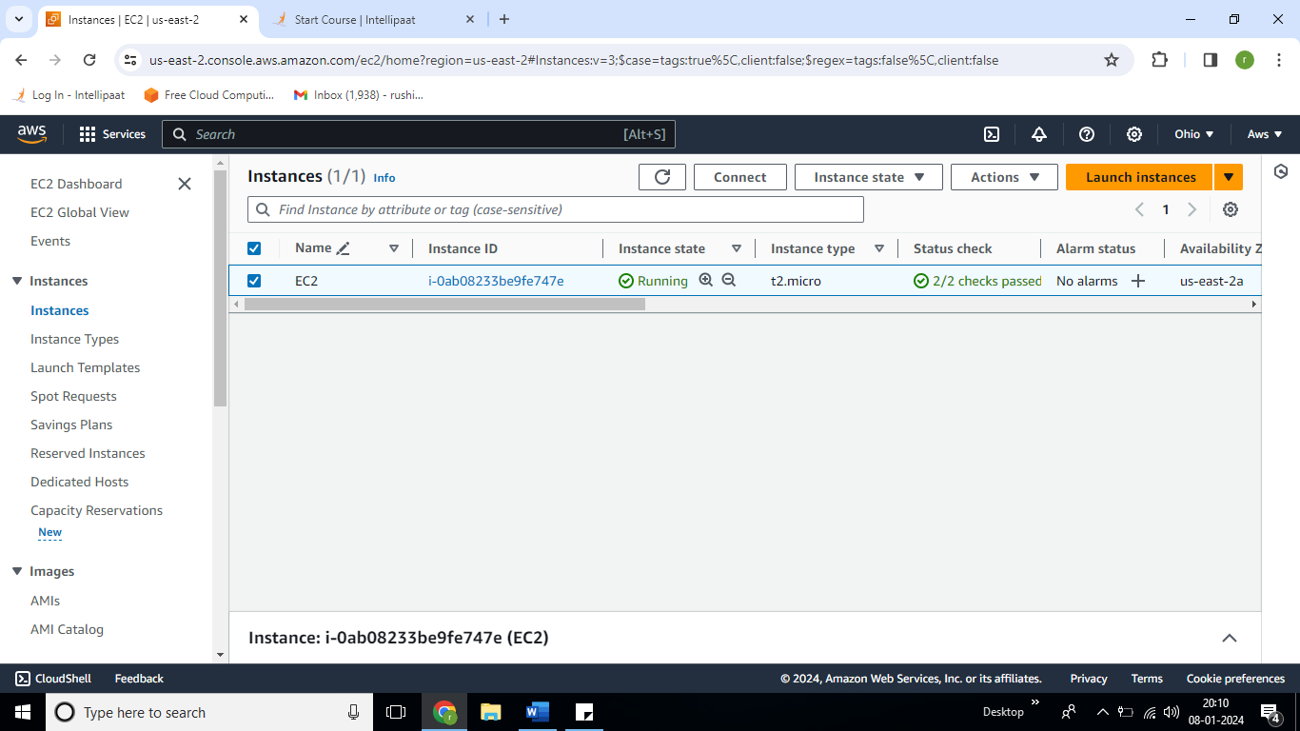
2. Now we connect mysql with the RDS. For that we will create Database with mysql.  
   Go to RDS and create database.

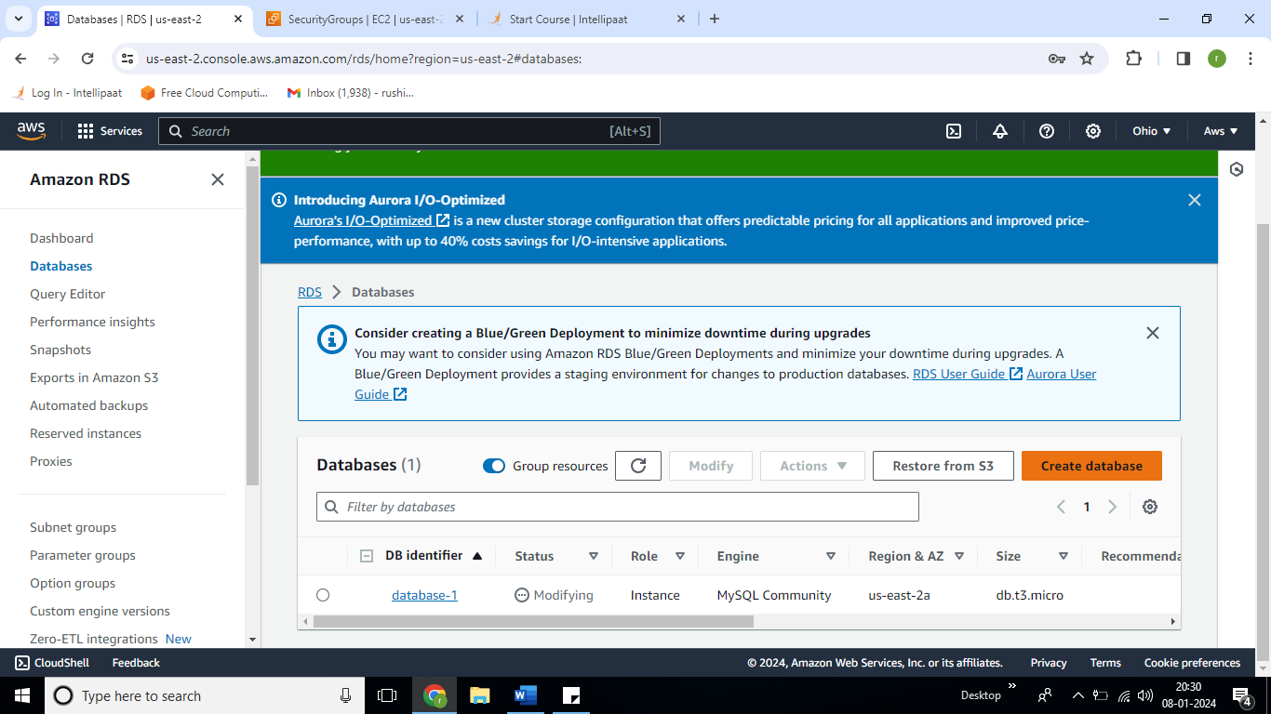

1. Now connect Putty with EC2 and run these all commands:  
   sudo apt-get update  
   sudo apt-get install apache2

sudo add-apt-repository -y ppa:ondrej/php

sudo apt install php5.6 mysql-client php5.6-mysqli

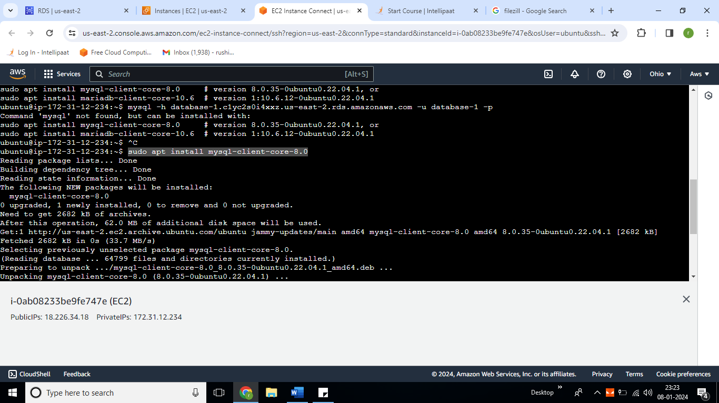

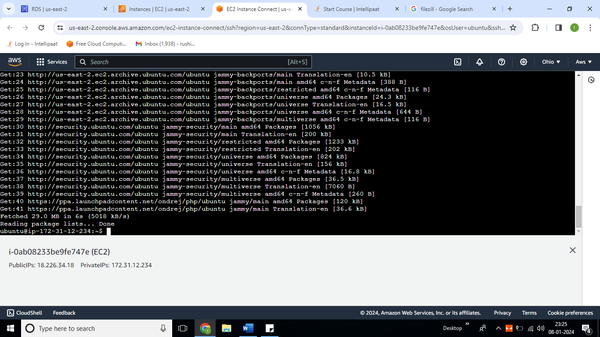

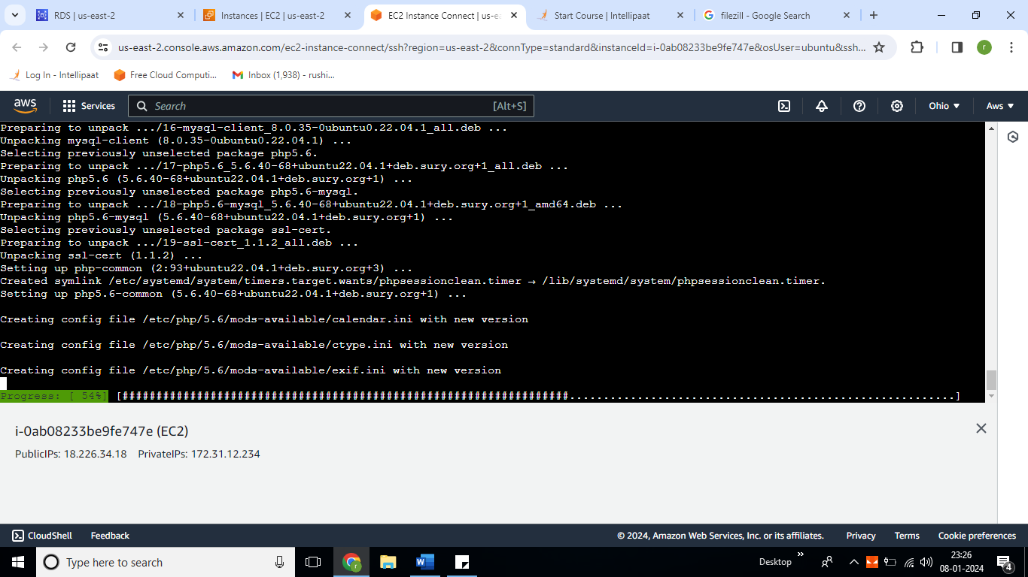

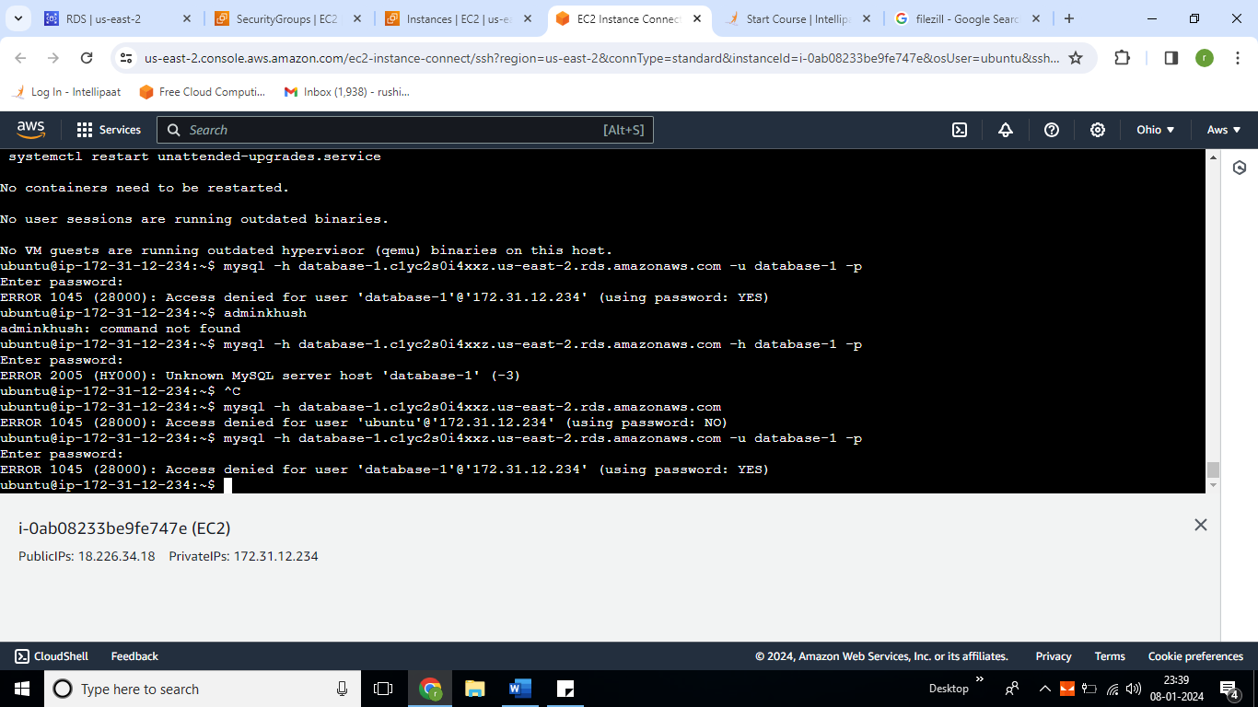

* Go to your EC2 Instance Security Group and select your group id.

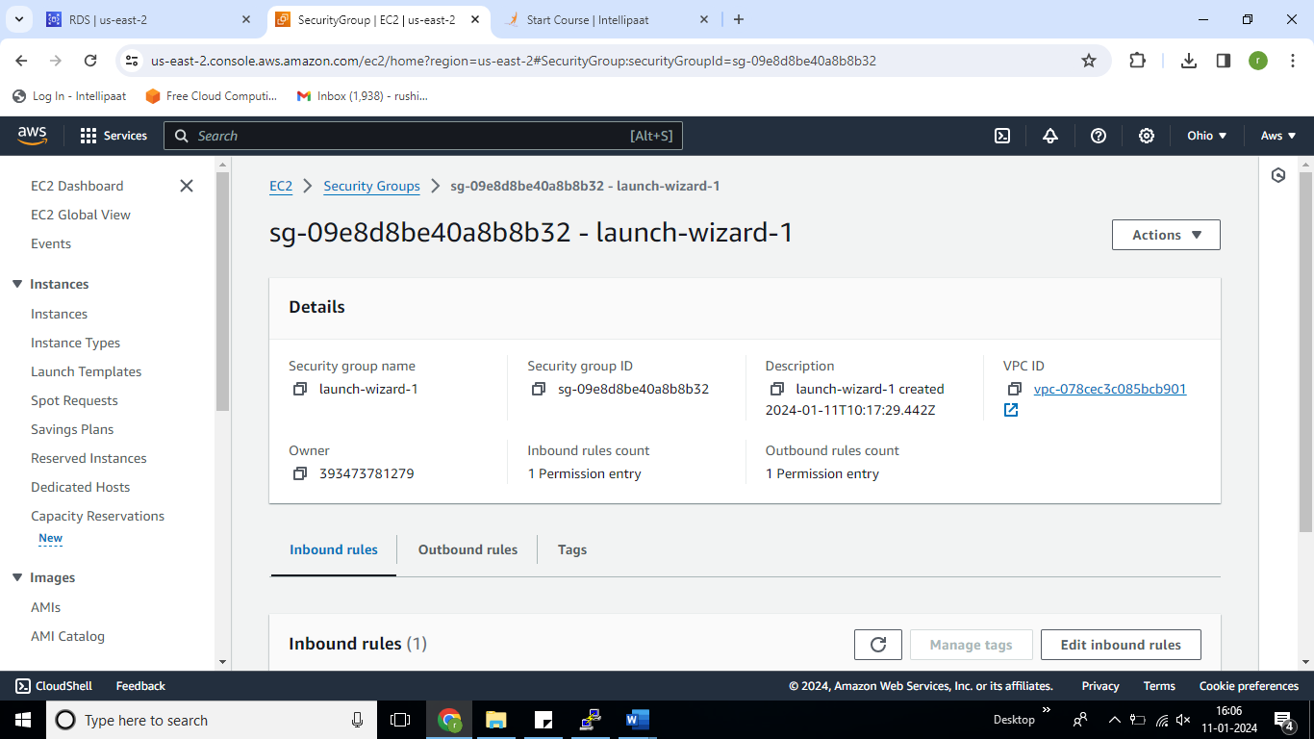

* We can see the endpoint and port umber of a RDS.

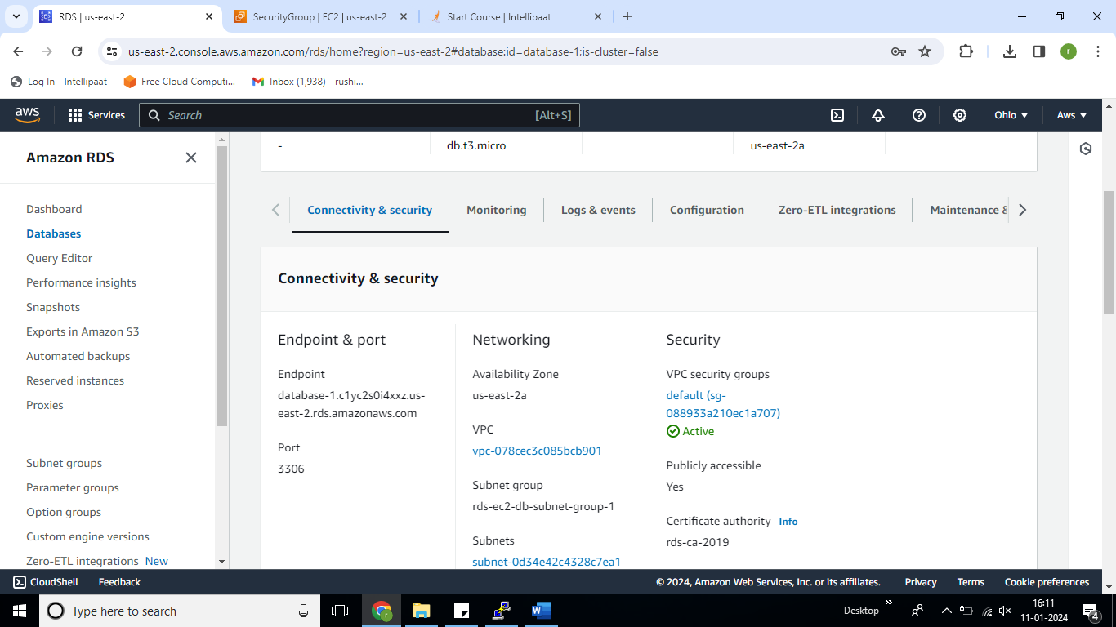

* We have added the security group id in RDS.

-----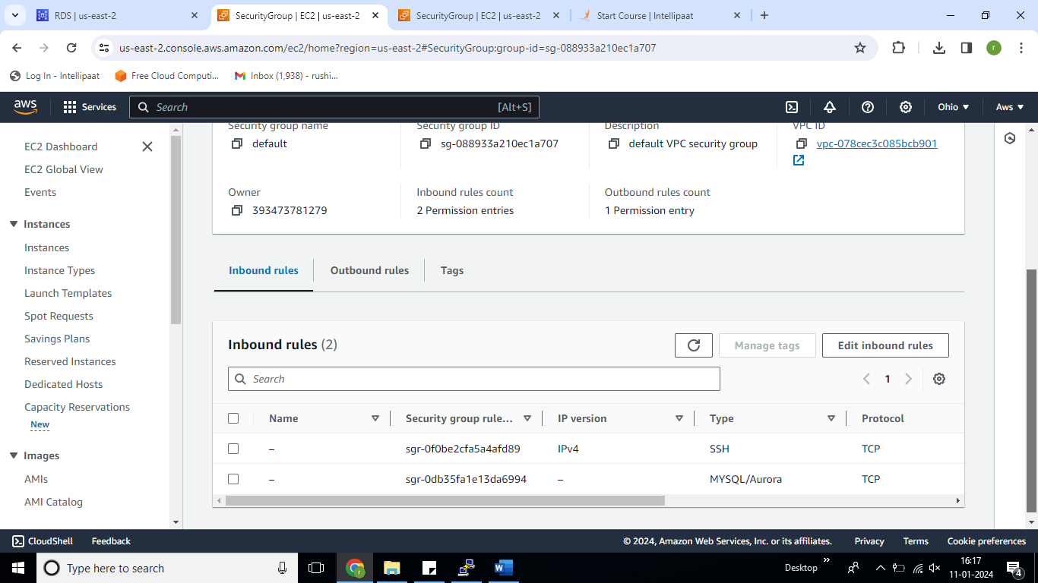-

* Now we will run the command:

mysql -h database-1.c1yc2s0i4xxz.us-east-2.rds.amazonaws.com -u admin -password

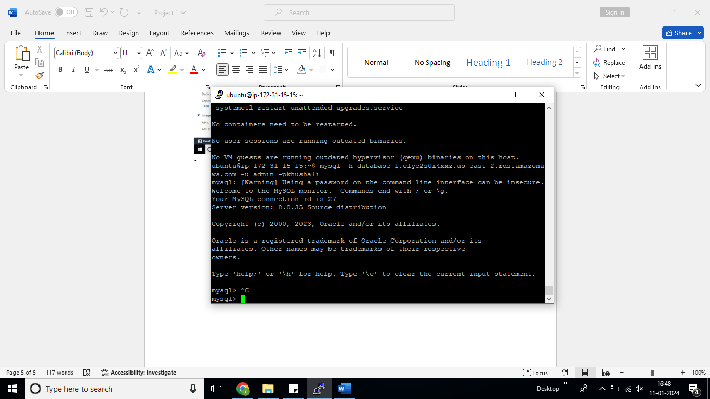

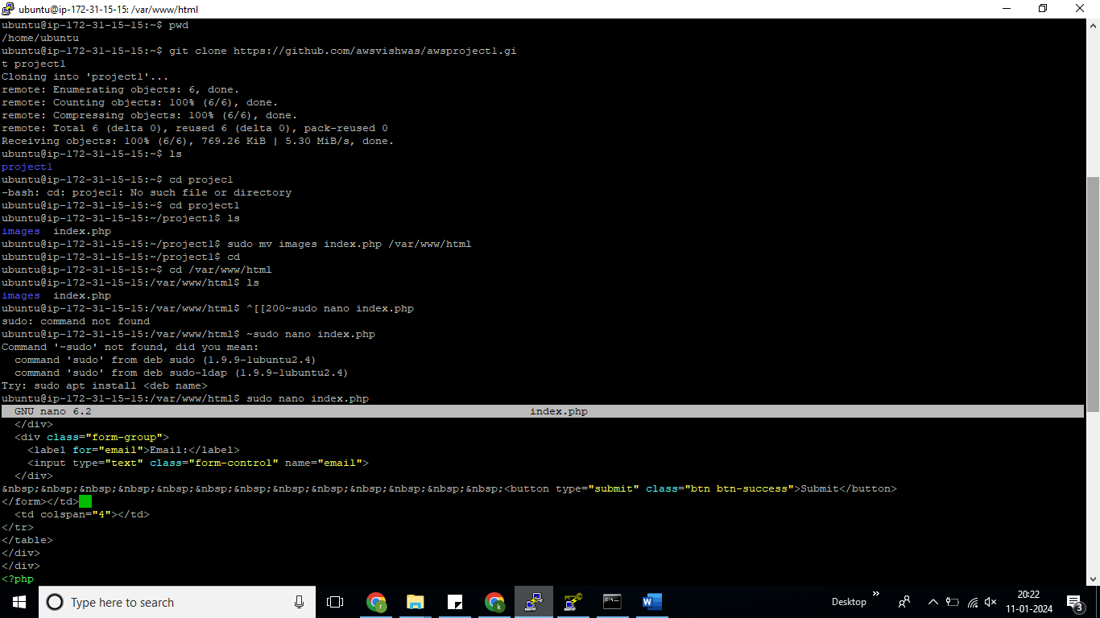

* Now when you will try, and copy paste the Public IP of your EC2 Instance

